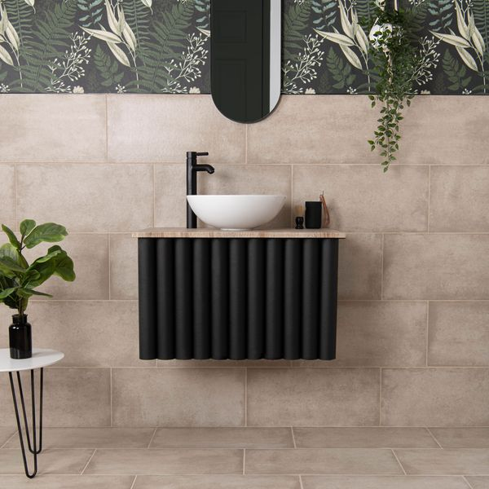**Samphire Matt Beige Tiles:**

## **Product Description**

**Gorgeous stone effect style**

Create a natural interior space with our Samphire Beige Stone Effect Porcelain Tiles. Made from durable porcelain, they feature a mottled stone effect design that embodies the modern, yet rustic feel that’s so popular in interior design. The tiles’ textured surface and natural matt finish are reminiscent of natural stone, forming a simple, elegant look in your home that’s made to last.

**What’s special about these tiles?**

> Soft beige hue  
> Naturalistic textured surface  
> Durable and hardwearing   
> Long lasting and easy to clean

## **Product Info**

* Product ID 45697
* Tiles Per SQM 5.6115463177033
* Sale by Per SQM
* Size 298x598x8mm
* Weight 3.30 KG
* Material Type Porcelain
* Finish Matt
* Colour Beige/Ivory
* Suitability Floors, Walls
* Area Of Usage Internal
* Grade 4
* Rectified Edge No
* Underfloor Heating Yes
* Thickness (mm) 8